Report of DE assignment [F18]

Introduction

Author: Ruslan Sabirov
Group: B17-02
GitHub: github.com/russabirov1998/DE

Exact solution
Exact solution of the Initial Value Problem

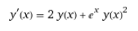
— Bernoulli equation
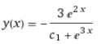
— Solution of Differential equation
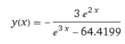
— Solution of IVP (initial value problem) — Exact solution

x_discont = 1.38847 — Point of discontinuity (when denominator of exact solution is equal to 0)

Structure of the program
Structure of the program

Program consist of modules import part, Numerical_mathods class and Main part
import part
import math — for e constant
import numpy as np — for working with array of x-coordinates
import plotly — for plotting
import plotly.graph_objs as go — for creating objects to plot
class Numeric_methods()
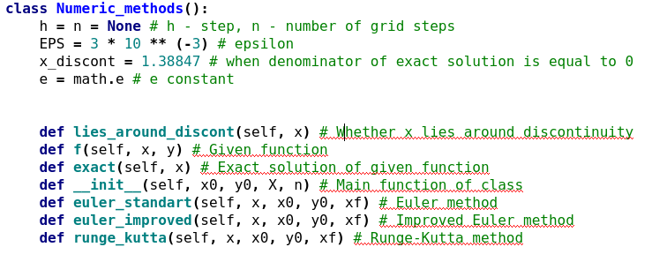
main part
Creating an object of class Numveric_methods with arguments x0, y0, X, n

Description of methods
Description of each method (there are three methods) with excerpts of code and some comment that explains what the code does.
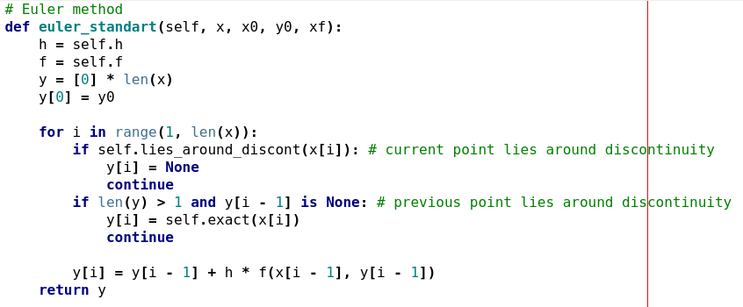
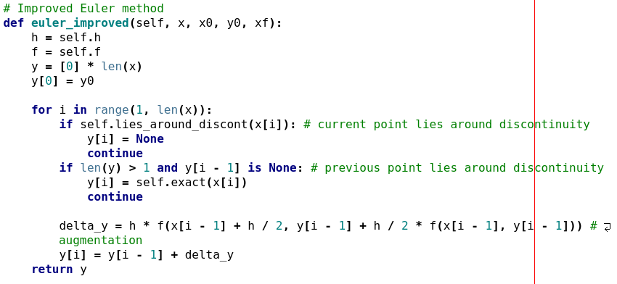
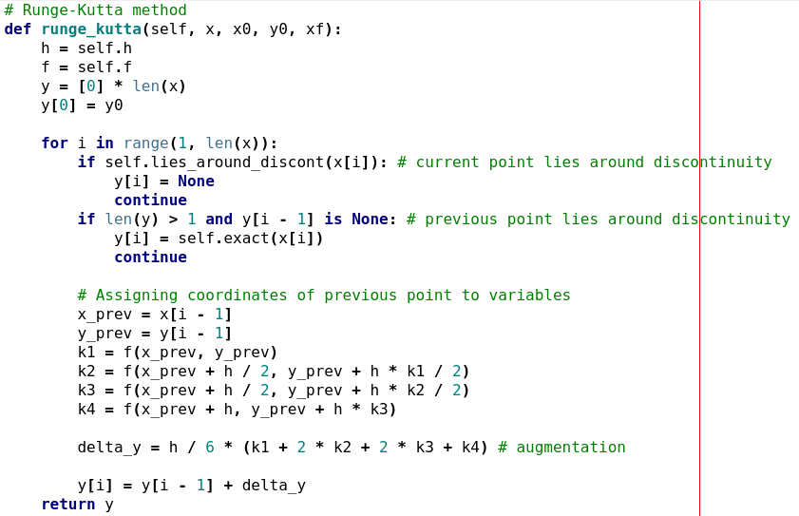

Solution graph
Display of the graphs the program displays (what I should get if I run it, but I would like to see the output without to have to run it - in live grading I can check if the graphs of the report correspond to what you get on your computer)
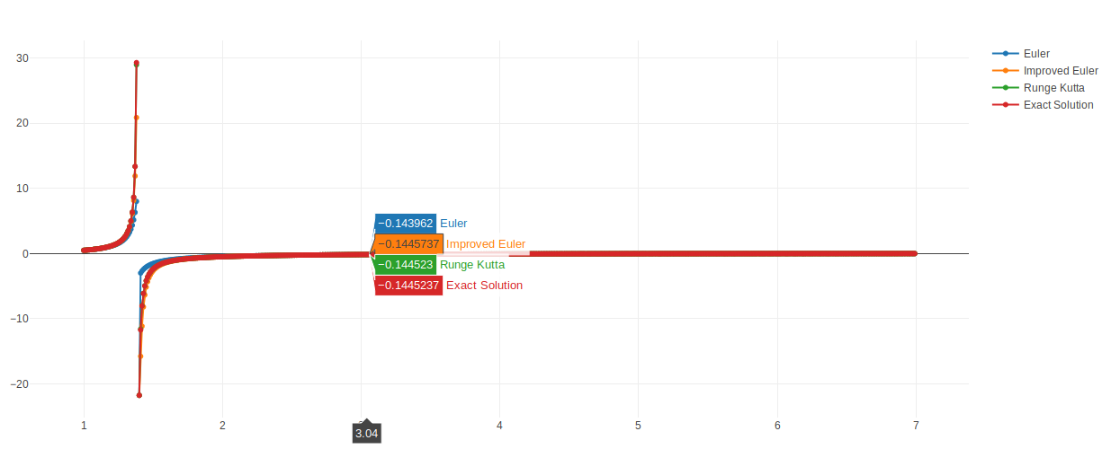Illustration 1: X = 7
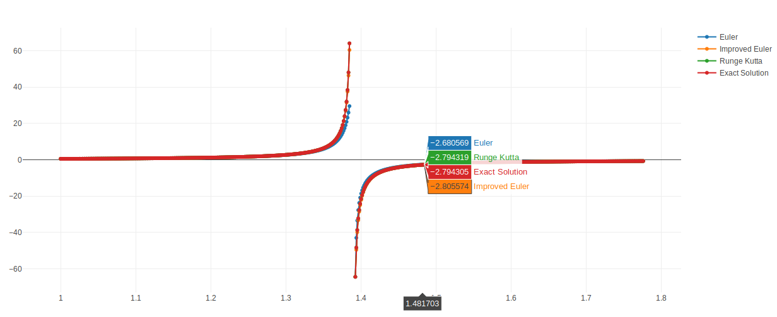Illustration 2: X = (x_discont - x0) * 2 + x0 = 1.77694

Truncation graph
And, the last but not the least: A graph with three plots that show the global truncation error for each method in function of the number of steps (of course if the number of steps increases, then the error decreases - we want to compare how it decreases for each method and to see which method is the best one).
Illustration 3: Graph of truncation errors over number of steps

Code
GitHub: github.com/russabirov1998/DE

